Isotopes Practical Model answer

- If the initial water vapour has δ¹⁸O = -10‰ and ε¹⁸O _{liquid-vapour} = 9.4‰,

δ¹⁸O = δ¹⁸O_{o} + ε ln f

For f = 0.9 (ie 10% loss of mass , ln 0.9 = -0.10536 then

δ¹⁸O = −10.0 + 9.4 ln 0.9 = −10.0 + 9.4 x -0.10536 = -10.9904‰

Rain falling from this cloud will have an isotopic composition of:
-10.9904‰ + ε = -1.59039‰ but assuming single step process here so always use initial water vapour of -10 regardless of f. (This gives a pretty good approximation of global water fractionation).

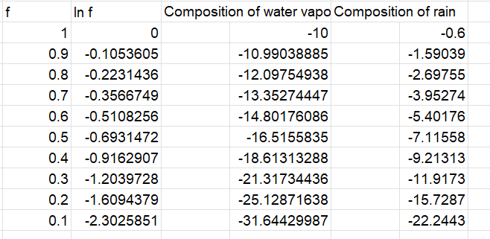

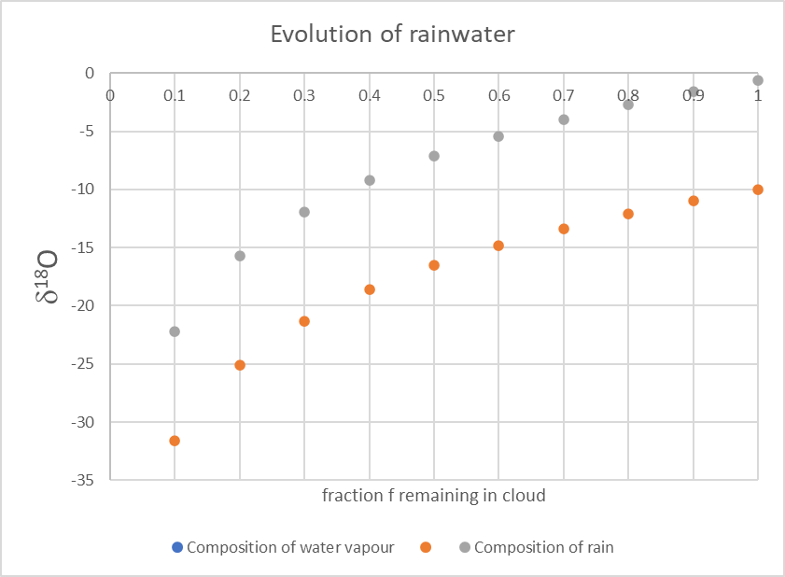

2) Carbonates from the last glacial maximum record a global ocean δ¹⁸O of +1.5‰. Assuming this difference is entirely due to loss of ocean water that is locked up as snow/ice precipitation, calculate the mass of water lost to the ice cap using ε¹⁸O from q1 22.2‰. Assume δ¹⁸O today is 0‰.

To reduce the ocean today by -1.5‰ we need to calculate f for:

δ¹⁸O = δ¹⁸O_{o} + ε ln f

where δ¹⁸O_{o} = 1.5‰, δ¹⁸O = 0‰ and ε = 22.2‰ to give:

0 = 1.5 + 22.24 ln f

-1.5/22.24 = -0.06757 = ln f

f = e^{-0.06757} = 0.9347

This is the mass fraction of the ocean remaining which causes a change in ocean isotopic
composition by 1.5‰.

What would this mass correspond to in terms of sealevel drop?

Mean depth of Worlds Ocean = 3794m

Crudely, if the oceans are reduced to 93.47% of current volume, then average depth will be 0.9347*3794m = 3546m, corresponding to a sea level nearly 250m lower at the last glacial maximum. Sea level height at LGM approx. 120m lower. So double the observed sea level change but this is to be expected because 1.5‰ is probably not the change in sea water composition - from the lecture, approx. 0.7-0.8‰ is change in water composition (direct measurement from pore fluids) which reduce expected sea level change to 0.75/1.5x248=124m. Remarkably consistent with 120m!

Note: assumption that ocean temperature constant – thermal expansion/contraction of oceans also plays a significant role in ocean volume.

